
Week 6 Homework: Grade 1 Science
Name: ………………………………
Class: ………………………………
Score out of 15: …………………...

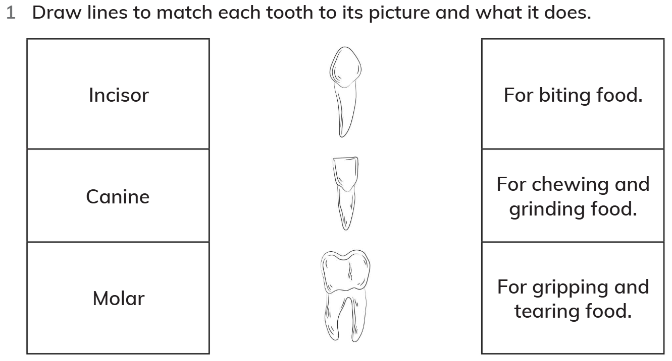
(6 marks)

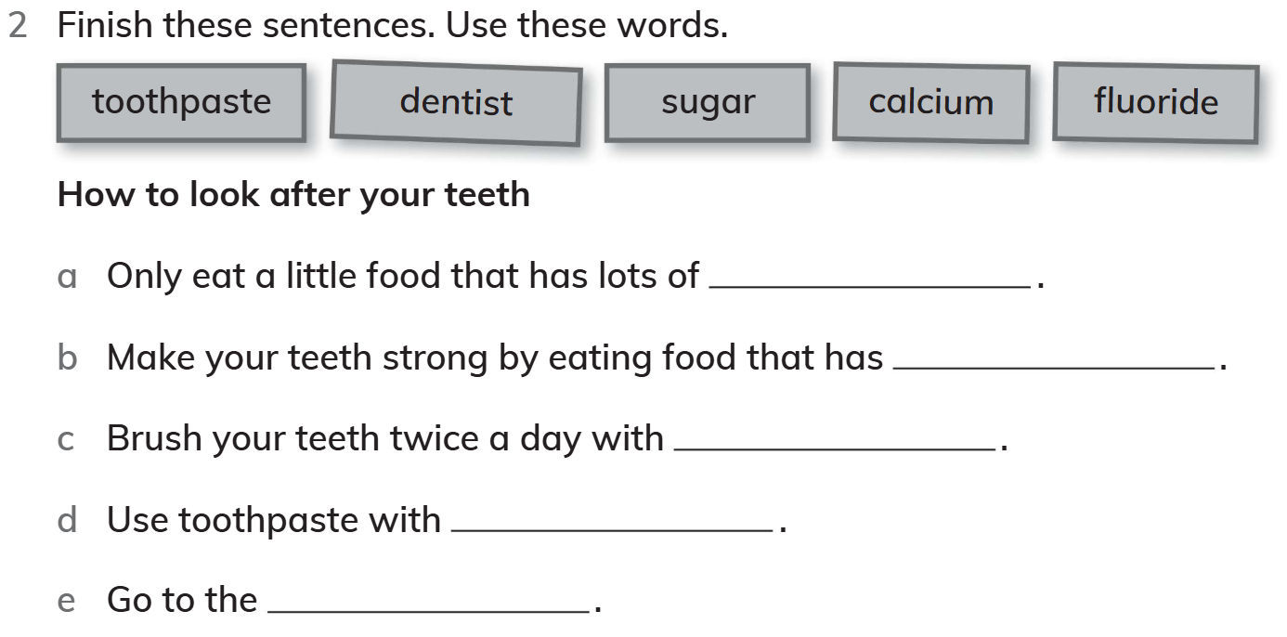
(5 marks)
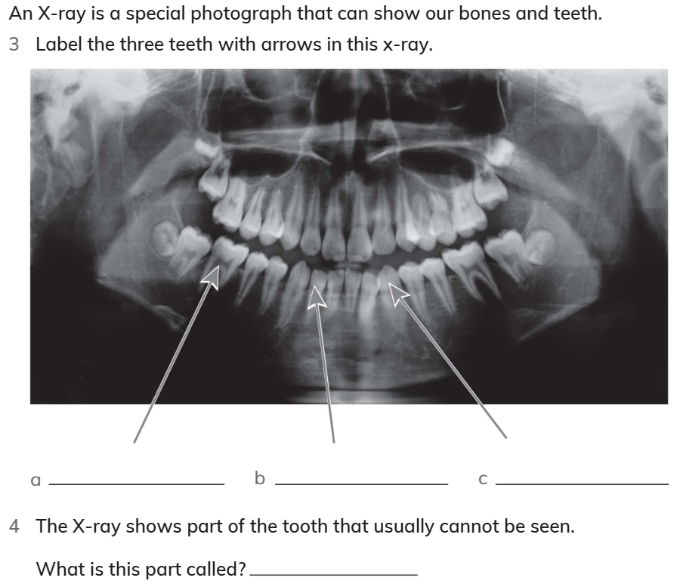
(4 marks)

